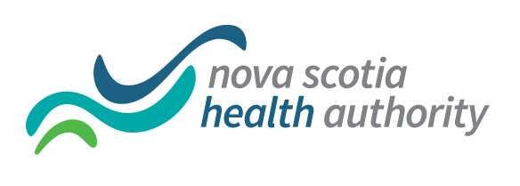
Nursing Grand Rounds
Monday June 25, 2018
Royal Bank Theatre


Topic: Connecting the Patient to the Plan & the Plan to the Patient

Presenters:

Tara Sherwood-Clinical Nurse Educator
Lynn Boudreau-Physiotherapy Practice Coordinator

Time: 12:00-12:45
Bring your lunch

