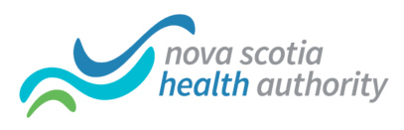

Central Zone Dental Benefit Renewal
(Important message to employees with dental benefits under Great-West Life)
The annual renewal of the Dental Plan under the NSHA Central Zone benefit program has been completed and there will be rate changes.
Your pay deposited on June 8 will reflect the renewal rate changes to this benefit.
Per pay dental plan deduction will be as follows:
[Please note: if you are paying 100% of the premium, you will be responsible for both the EE and ER amounts]

Employees (Cost shared: 35% Employee (EE)/ 65 % Employer (ER))
 | Current Rates |  | Renewal Rates |  | Per Pay Change
Single Rate | EE $6.99 | ER $12.98 | EE $7.34 | ER $13.63 | EE $0.35 | ER $0.65
Family Rate | EE $14.93 | ER $27.72 | EE $15.67 | ER $29.11 | EE $0.75 | ER $1.39

We apologize for the short notice of this increase.
Should you have any questions please do not hesitate to contact Cynthia Fox at 902-473-5827.

